CRITERIA REFERENCED ASSESSMENT TEAM REPORT FOR M.Sc(HONS) DEGREE PROGRAM OF DEPARTMENT OF PLANT PATHOLOGY
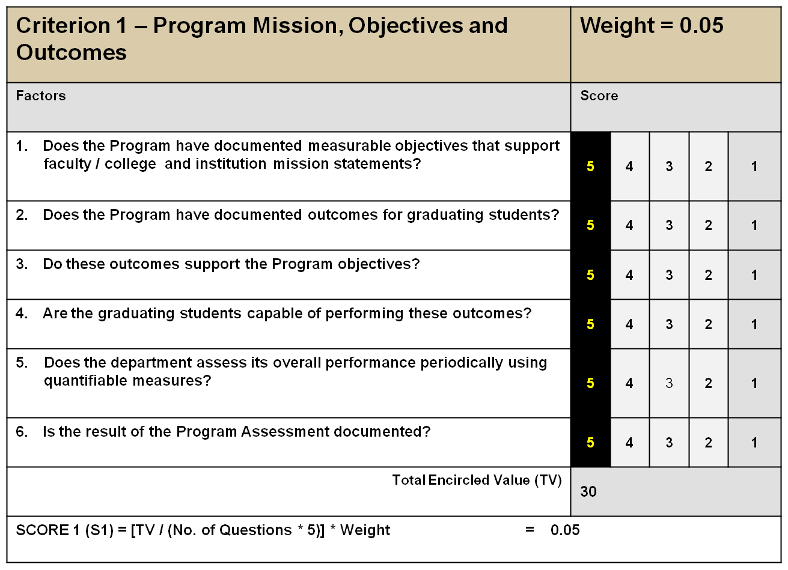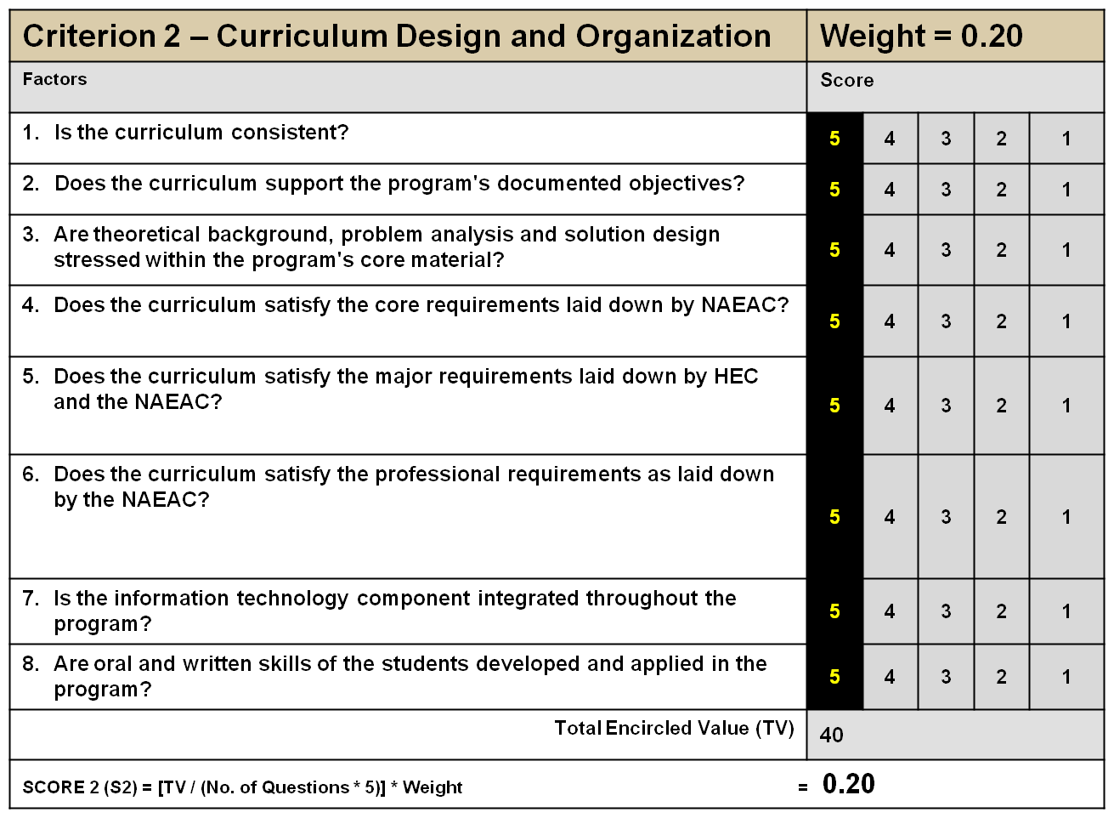
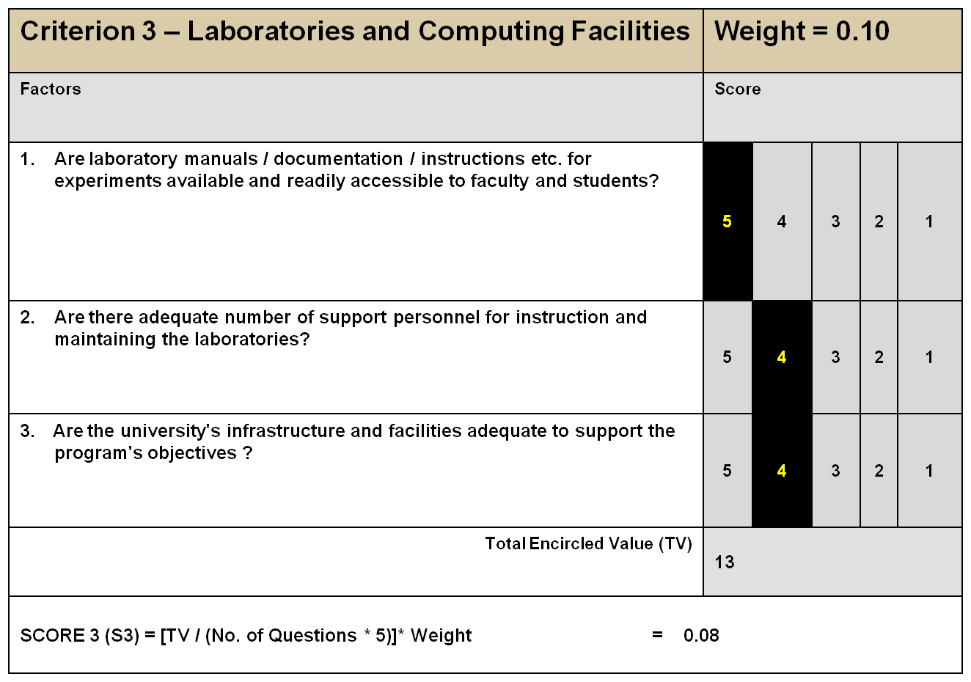
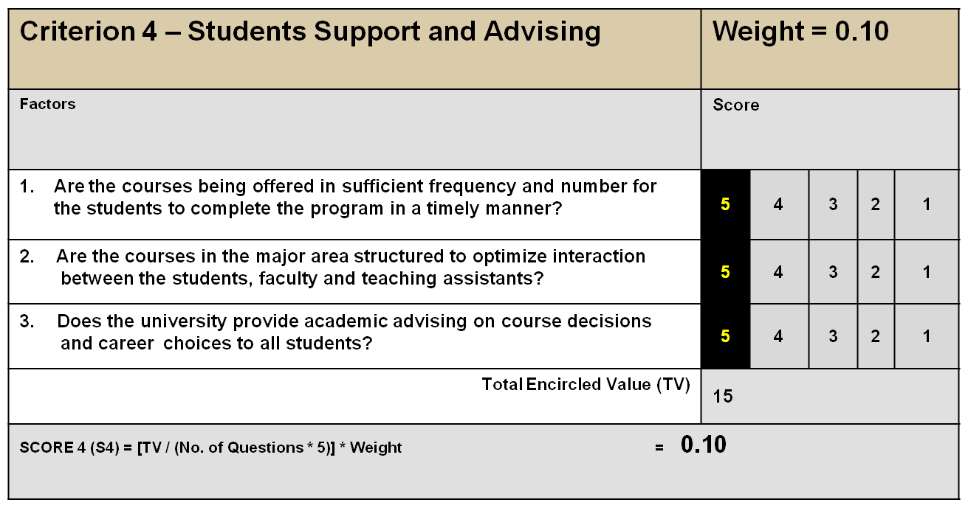

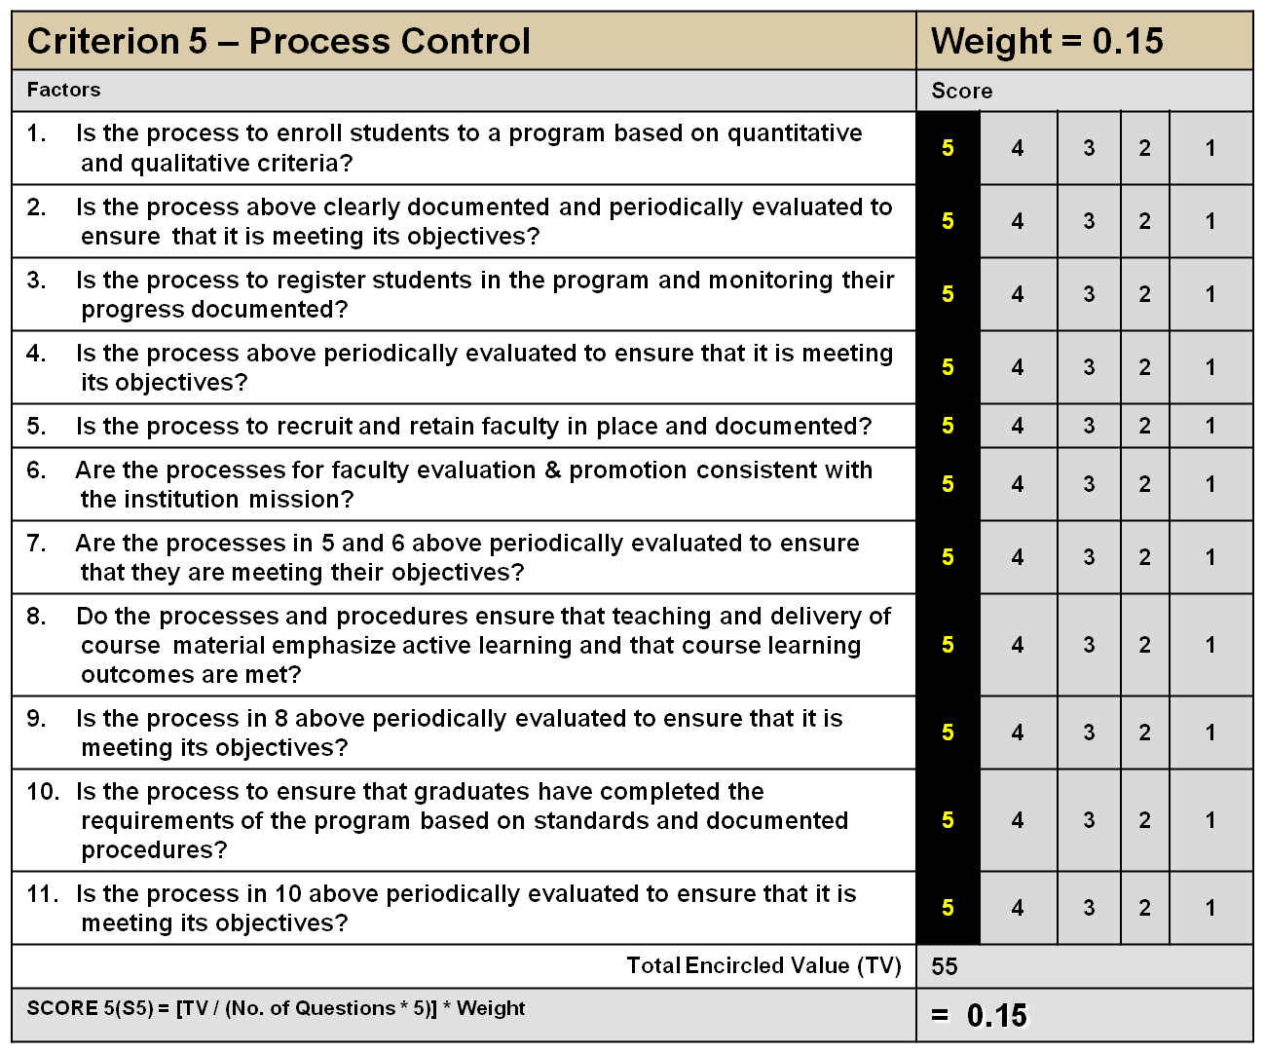

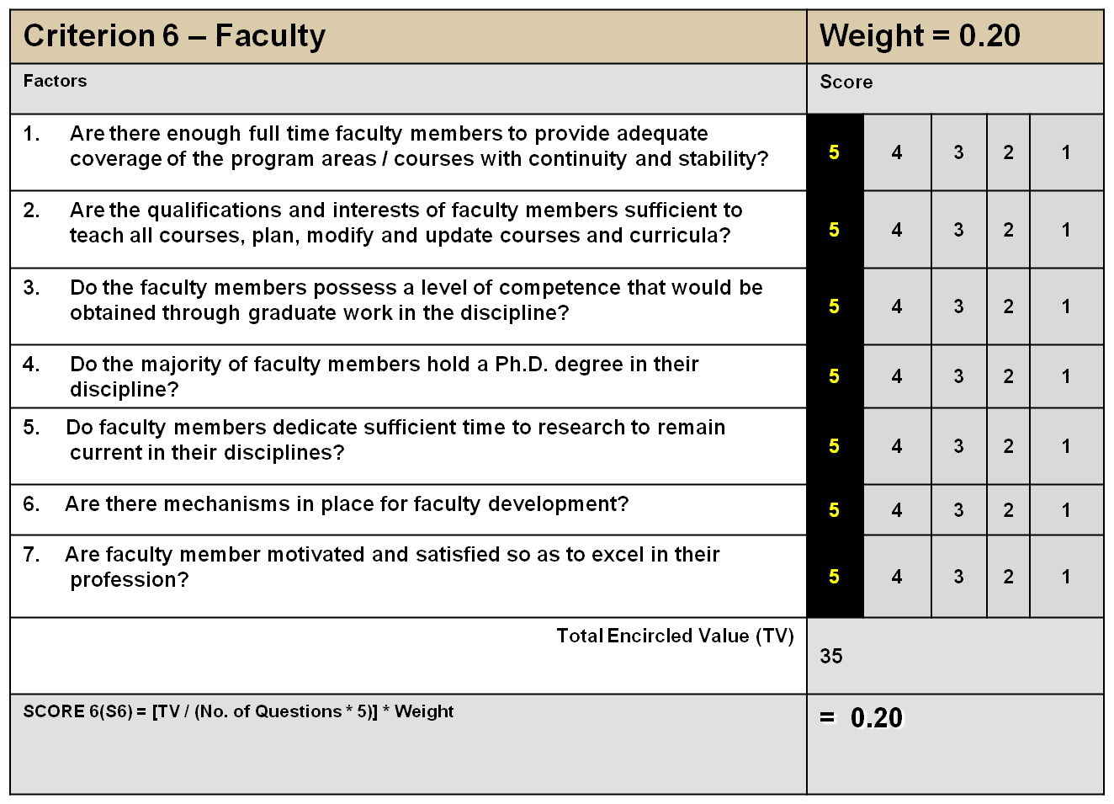
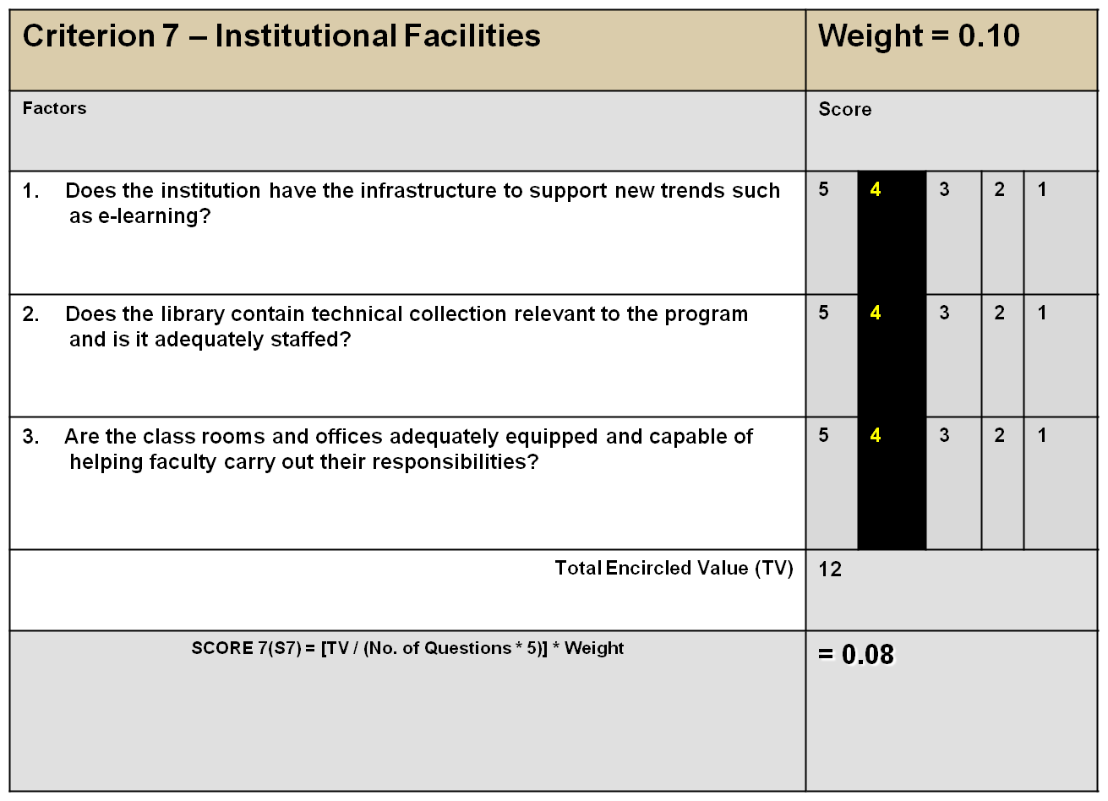

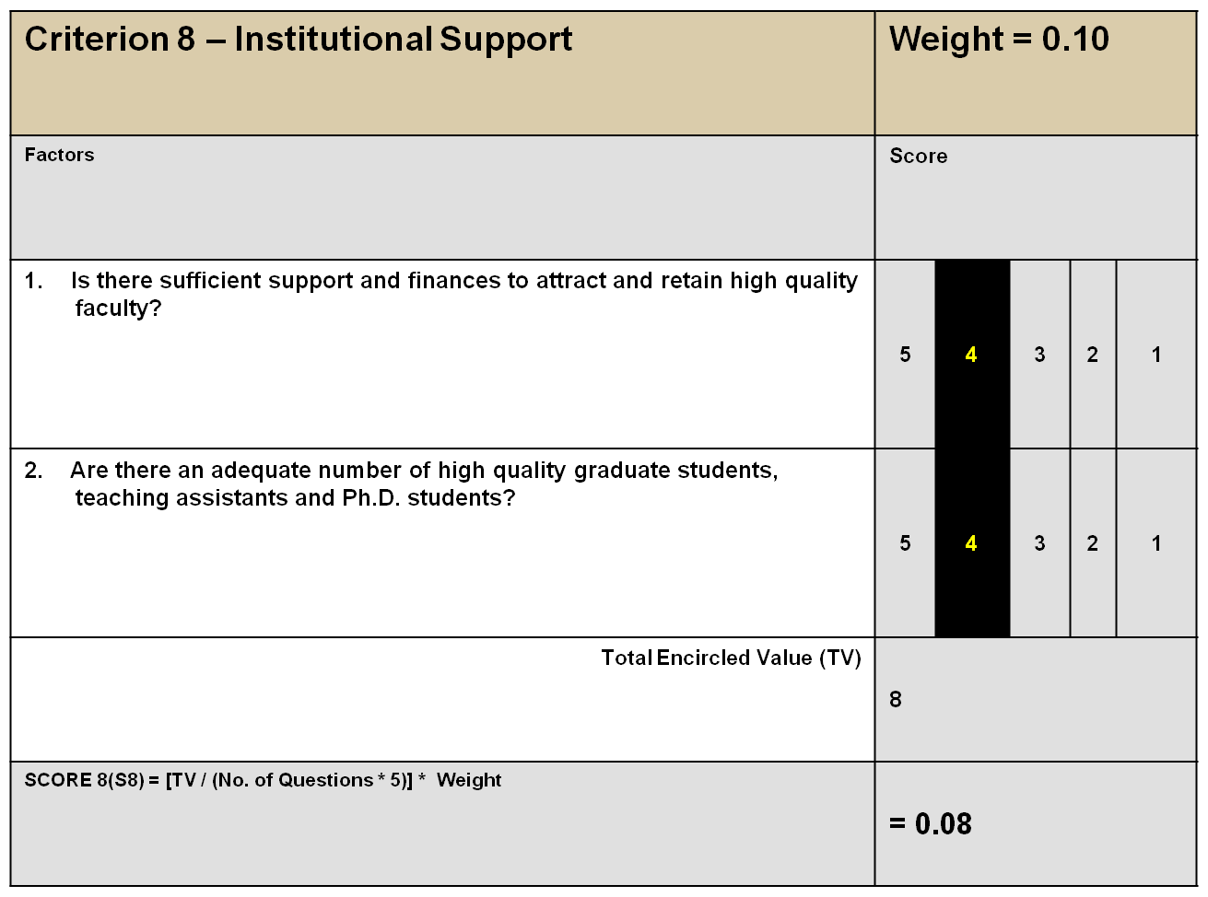

Overall Assessment Score:
S1 + S2 + S3 + S4 + S5 + S6 + S7 + S8 = 0.94
REMARKS:
Assessment Teams (AT) diagnosed some short comings using Criteria 3,7 & 8 and found that the number of supporting staff is insufficient and professional capacity is not at par with the requirement of the Department. The students have limited access on e-learning, no separate class rooms and need more offices for the faculty and Ph.D students. The Department is not independent in financial matters in day-to-day needs and improvement of the efficiency of the faculty as well as supporting staff.
There is dire need of appointment of more qualified supporting staff in laboratories and efficiency of the existing staff could be improved through professional trainings. The department needs a separate computer laboratory with not less than 10 internet connected computers. Due to the increase in number of the students, separate class rooms at least three class rooms are urgently required. It is Proposed that operational funds of the Department should be made available to the Chairman on annual basis.

